Power Quality Report
Power Quality Report: T

Contents
Chapter 1 (Feeder 1) 3
Chart: Trend: Frequency Frequency (Auto) Min/Max, PQZIP 02/13/2025 01:16:43 PM 4
Chart: Trend: RMS Voltage, PQZIP 02/13/2025 01:16:43 PM 5
Chart: Events Table: PQZIP 02/13/2025 01:16:43 PM 6
Chart: Unipede Table: PQZIP 02/13/2025 01:16:43 PM 10
Chart: Spectrum: IEC 61000-4-30 Voltage and Current - Harmonics Amplitude (%) Voltage, PQZIP 02/13/2025 01:16:43 PM 12

Chapter 1 (Feeder 1)

Report start time: 02/21/2024 12:00:00.000000 AM
Report end time: 02/20/2025 12:00:00.000000 AM

Chart: Trend: Frequency Frequency (Auto) Min/Max, PQZIP 02/13/2025 01:16:43 PM

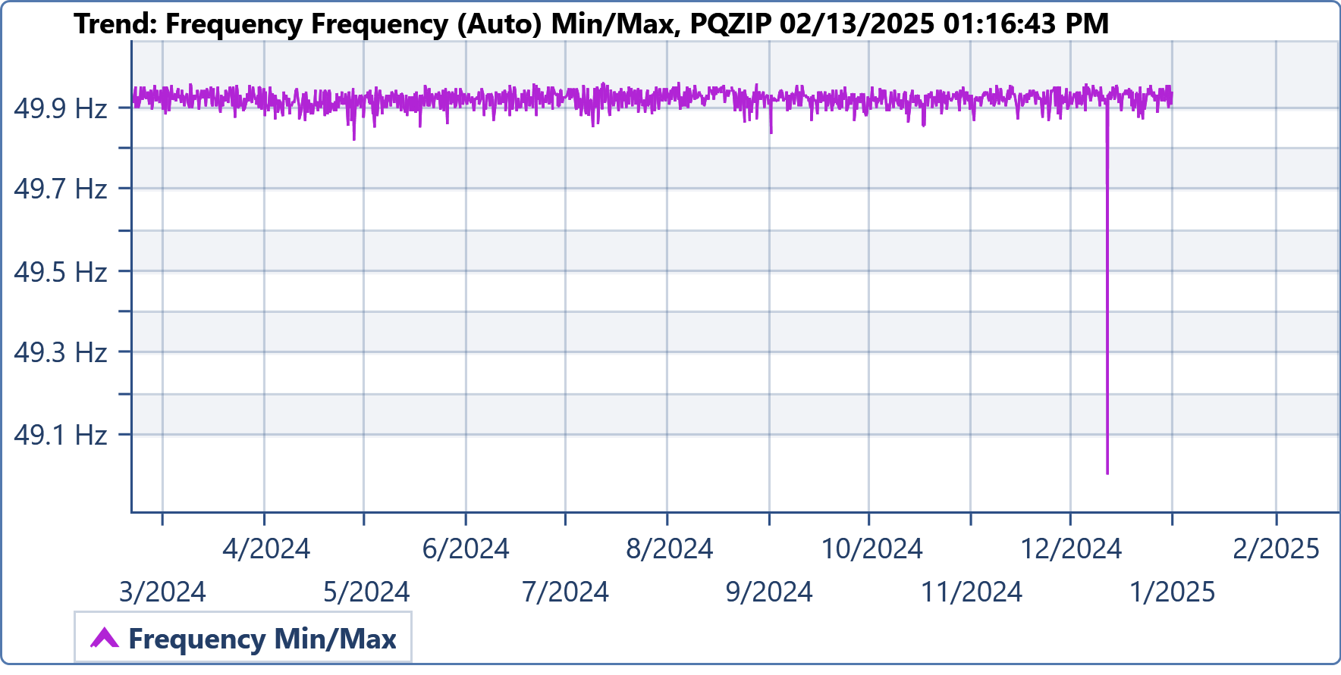
Component | Parameter | Min | Max | Average
PQZIP 02/13/2025 01:16:43 PM | Frequency (Auto) | 49.005 Hz | 50.137 Hz | 50.003 Hz

Charts Notes:

Chart: Trend: RMS Voltage, PQZIP 02/13/2025 01:16:43 PM

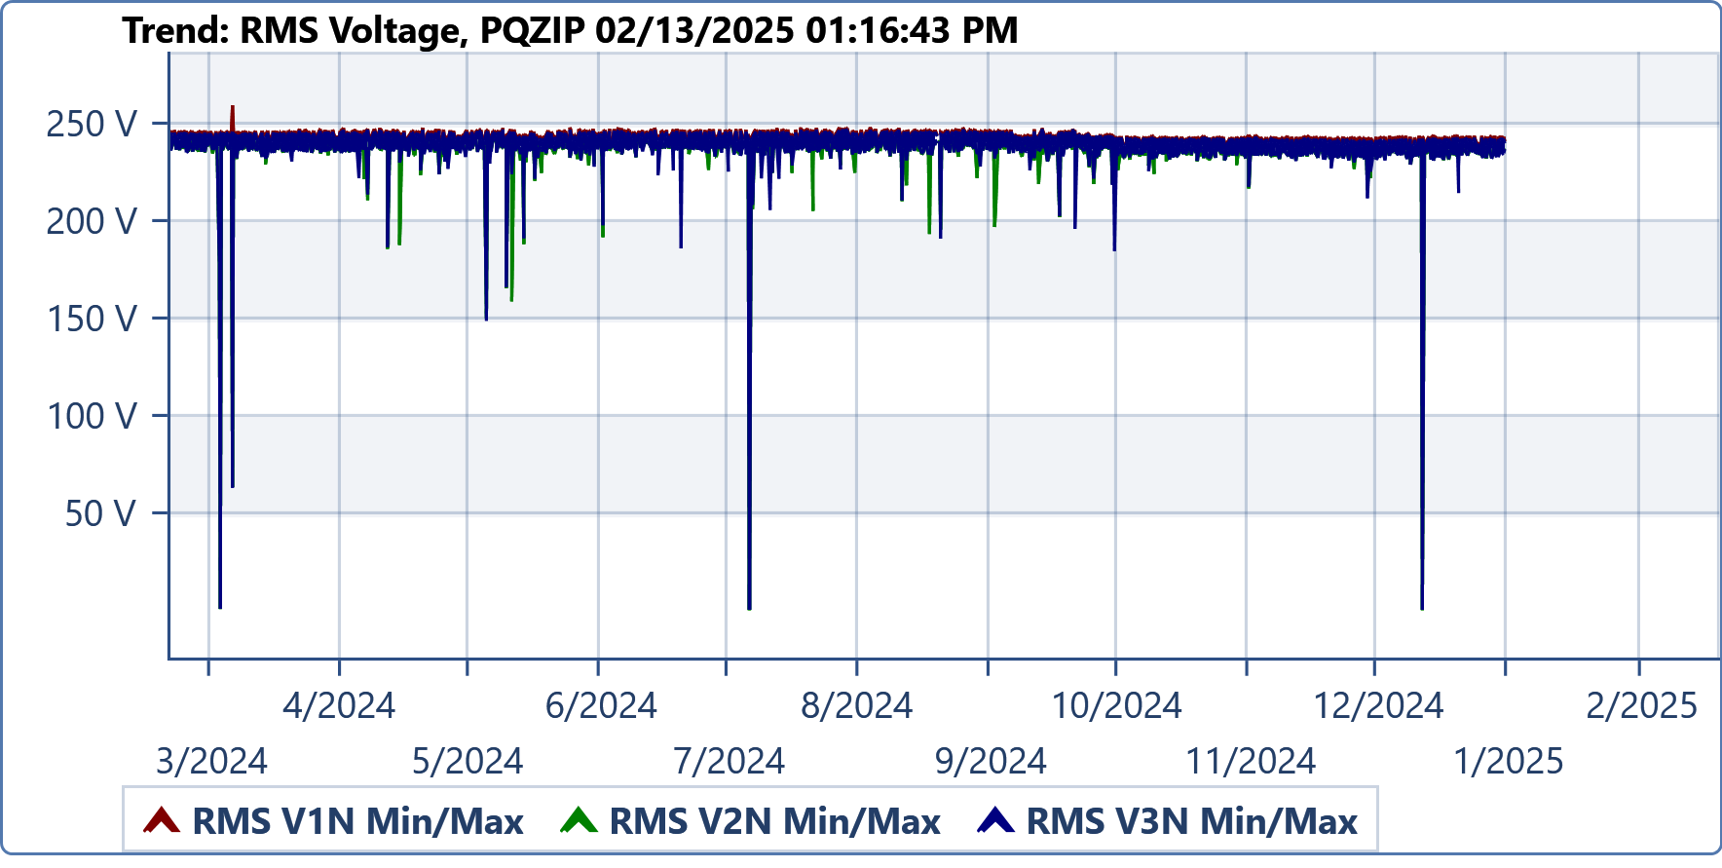
Component | Parameter | Min | Max | Average
PQZIP 02/13/2025 01:16:43 PM | RMS V1N (Auto) | 0 V | 260.656 V | 243.485 V
PQZIP 02/13/2025 01:16:43 PM | RMS V2N (Auto) | 0 V | 248.6 V | 242.521 V
PQZIP 02/13/2025 01:16:43 PM | RMS V3N (Auto) | 0.159 V | 248.355 V | 242.5 V

Charts Notes:

Chart: Events Table: PQZIP 02/13/2025 01:16:43 PM

ID | Name | Type | Phase | Severity | Start time | End time | Duration | Value | Value (% from ref.) | Generated by | Component name | Event Source
7509 | Dip | Dip | V1N,V2N,V3N | 111 | 12/12/2024 06:42:12.818646 PM | 12/12/2024 06:42:13.308887 PM | 00:00.490240 | 140.2344 | 60.74219 | 4420 Device | PQZIP 02/13/2025 01:16:43 PM | Upstream
7506 | Dip | Dip | V1N,V2N,V3N | 111 | 12/12/2024 06:41:41.892915 PM | 12/12/2024 06:41:42.393171 PM | 00:00.500255 | 140.1016 | 60.69336 | 4420 Device | PQZIP 02/13/2025 01:16:43 PM | Upstream
7505 | Dip | Dip | V1N,V2N,V3N | 111 | 12/12/2024 06:41:40.222252 PM | 12/12/2024 06:41:40.712457 PM | 00:00.490204 | 140.1563 | 60.69336 | 4420 Device | PQZIP 02/13/2025 01:16:43 PM | Upstream
7498 | Voltage drop-down | Voltage drop-down | V1N,V2N,V3N | 0 | 12/12/2024 06:40:19.740873 PM | 12/12/2024 06:40:19.740873 PM |  | 4.4104 | 1.953125 | 4420 Device | PQZIP 02/13/2025 01:16:43 PM | Unknown
7501 | Supply Voltage Interruptions | Supply Voltage Interruptions | V1N,V2N,V3N | 156 | 12/12/2024 06:40:19.740873 PM | 12/12/2024 06:40:25.879812 PM | 00:06.138938 | 0.077137 | 0.048828 | 4420 Device | PQZIP 02/13/2025 01:16:43 PM | Upstream
7502 | Dip | Dip | V1N,V2N,V3N | 255 | 12/12/2024 06:40:19.530805 PM | 12/12/2024 06:40:25.929712 PM | 00:06.398907 | 0.077137 | 0.048828 | 4420 Device | PQZIP 02/13/2025 01:16:43 PM | Upstream
7172 | Flickering | Flickering | V2N,V3N | 22 | 11/29/2024 07:00:00.363381 PM | 11/29/2024 09:00:00.363381 PM | 120:00.000000 | 1.244984 | 75.53711 | 4420 Device | PQZIP 02/13/2025 01:16:43 PM | Unknown
5678 | Dip | Dip | V1N,V3N | 70 | 10/01/2024 06:31:44.759245 AM | 10/01/2024 06:31:44.809344 AM | 00:00.050099 | 184.5938 | 79.93164 | 4420 Device | PQZIP 02/13/2025 01:16:43 PM | Unknown
5442 | Dip | Dip | V1N,V3N | 59 | 09/22/2024 02:33:19.701615 AM | 09/22/2024 02:33:19.751546 AM | 00:00.049931 | 196.8438 | 85.25391 | 4420 Device | PQZIP 02/13/2025 01:16:43 PM | Unknown
5341 | Dip | Dip | V2N,V3N | 55 | 09/18/2024 06:14:22.807066 AM | 09/18/2024 06:14:22.866903 AM | 00:00.059837 | 201.5625 | 87.30469 | 4420 Device | PQZIP 02/13/2025 01:16:43 PM | Upstream
4963 | Dip | Dip | V1N,V2N | 53 | 09/03/2024 05:05:54.201251 AM | 09/03/2024 05:05:54.251315 AM | 00:00.050064 | 204.3281 | 88.52539 | 4420 Device | PQZIP 02/13/2025 01:16:43 PM | Unknown
4951 | Dip | Dip | V1N,V2N | 65 | 09/03/2024 12:52:36.280425 AM | 09/03/2024 12:52:36.325580 AM | 00:00.045154 | 190.6719 | 82.56836 | 4420 Device | PQZIP 02/13/2025 01:16:43 PM | Unknown
4624 | Dip | Dip | V1N,V2N,V3N | 64 | 08/21/2024 03:49:37.751467 AM | 08/21/2024 03:49:37.811473 AM | 00:00.060006 | 191.8438 | 83.10547 | 4420 Device | PQZIP 02/13/2025 01:16:43 PM | Upstream
4575 | Dip | Dip | V1N,V2N | 61 | 08/18/2024 04:10:16.941553 PM | 08/18/2024 04:10:17.001559 PM | 00:00.060006 | 194.4688 | 84.22852 | 4420 Device | PQZIP 02/13/2025 01:16:43 PM | Upstream
4414 | Flickering | Flickering | V2N,V3N | 20 | 08/12/2024 04:00:00.413365 AM | 08/12/2024 06:00:00.413365 AM | 120:00.000000 | 1.092581 | 90.77148 | 4420 Device | PQZIP 02/13/2025 01:16:43 PM | Unknown
3877 | Dip | Dip | V1N,V2N | 52 | 07/22/2024 04:43:31.208271 AM | 07/22/2024 04:43:31.248255 AM | 00:00.039983 | 205.5625 | 89.01367 | 4420 Device | PQZIP 02/13/2025 01:16:43 PM | Unknown
3620 | Dip | Dip | V1N,V3N | 52 | 07/12/2024 04:37:20.541873 AM | 07/12/2024 04:37:20.591903 AM | 00:00.050030 | 205.1406 | 88.86719 | 4420 Device | PQZIP 02/13/2025 01:16:43 PM | Unknown
3486 | Voltage drop-down | Voltage drop-down | V1N,V2N,V3N | 0 | 07/07/2024 07:00:08.996737 AM | 07/07/2024 07:00:08.996737 AM |  | 1.282471 | 0.585938 | 4420 Device | PQZIP 02/13/2025 01:16:43 PM | Unknown
3492 | Supply Voltage Interruptions | Supply Voltage Interruptions | V1N,V2N,V3N | 255 | 07/07/2024 07:00:08.996378 AM | 07/07/2024 10:12:25.887003 AM | 192:16.890625 | 0 | 0 | 4420 Device | PQZIP 02/13/2025 01:16:43 PM | Upstream
3448 | Harmonics | Harmonics | V1N,V2N,V3N | 35 | 07/05/2024 06:41:44.706638 PM | 07/05/2024 06:51:44.706638 PM | 10:00.000000 | 3.177567 | 96.82617 | 4420 Device | PQZIP 02/13/2025 01:16:43 PM | Unknown
3069 | Dip | Dip | V1N,V3N | 68 | 06/21/2024 05:15:25.835168 AM | 06/21/2024 05:15:25.895022 AM | 00:00.059854 | 186.9375 | 80.95703 | 4420 Device | PQZIP 02/13/2025 01:16:43 PM | Unknown
2603 | Dip | Dip | V2N,V3N | 64 | 06/02/2024 04:31:58.690123 PM | 06/02/2024 04:31:58.750116 PM | 00:00.059992 | 191.9063 | 83.10547 | 4420 Device | PQZIP 02/13/2025 01:16:43 PM | Upstream
2135 | Dip | Dip | V2N,V3N | 67 | 05/15/2024 05:04:39.244701 AM | 05/15/2024 05:04:39.304592 AM | 00:00.059890 | 187.7969 | 81.34766 | 4420 Device | PQZIP 02/13/2025 01:16:43 PM | Unknown
2064 | Dip | Dip | V1N,V2N | 93 | 05/12/2024 03:17:00.842718 PM | 05/12/2024 03:17:00.927750 PM | 00:00.085032 | 158.2813 | 68.55469 | 4420 Device | PQZIP 02/13/2025 01:16:43 PM | Upstream
2022 | Dip | Dip | V2N,V3N | 86 | 05/11/2024 04:38:41.929571 AM | 05/11/2024 04:38:42.009581 AM | 00:00.080009 | 166.0781 | 71.92383 | 4420 Device | PQZIP 02/13/2025 01:16:43 PM | Upstream
1896 | Dip | Dip | V2N,V3N | 101 | 05/06/2024 05:15:32.618921 AM | 05/06/2024 05:15:32.694008 AM | 00:00.075087 | 148.7109 | 64.4043 | 4420 Device | PQZIP 02/13/2025 01:16:43 PM | Upstream
1389 | Dip | Dip | V1N,V2N | 67 | 04/16/2024 12:12:13.145069 AM | 04/16/2024 12:12:13.204924 AM | 00:00.059855 | 187.9688 | 81.39648 | 4420 Device | PQZIP 02/13/2025 01:16:43 PM | Unknown
1316 | Dip | Dip | V2N,V3N | 68 | 04/13/2024 05:46:09.036411 AM | 04/13/2024 05:46:09.106446 AM | 00:00.070035 | 186.4219 | 80.76172 | 4420 Device | PQZIP 02/13/2025 01:16:43 PM | Upstream
398 | Dip | Dip | V1N,V2N,V3N | 177 | 03/07/2024 08:11:18.644741 AM | 03/07/2024 08:11:19.154508 AM | 00:00.509766 | 63.02344 | 27.29492 | 4420 Device | PQZIP 02/13/2025 01:16:43 PM | Unknown
321 | Supply Voltage Interruptions | Supply Voltage Interruptions | V1N,V2N,V3N | 151 | 03/04/2024 02:05:00.966103 PM | 03/04/2024 02:05:02.886866 PM | 00:01.920763 | 0.089981 | 0.048828 | 4420 Device | PQZIP 02/13/2025 01:16:43 PM | Unknown
320 | Voltage drop-down | Voltage drop-down | V1N,V2N,V3N | 0 | 03/04/2024 02:05:00.966103 PM | 03/04/2024 02:05:00.966103 PM |  | 0.138847 | 0.097656 | 4420 Device | PQZIP 02/13/2025 01:16:43 PM | Unknown
322 | Dip | Dip | V1N,V2N,V3N | 239 | 03/04/2024 02:05:00.946250 PM | 03/04/2024 02:05:02.901939 PM | 00:01.955688 | 0.089981 | 0.048828 | 4420 Device | PQZIP 02/13/2025 01:16:43 PM | Upstream
308 | Dip | Dip | V2N,V3N | 75 | 03/04/2024 06:49:28.523698 AM | 03/04/2024 06:49:28.593754 AM | 00:00.070056 | 179.2891 | 77.63672 | 4420 Device | PQZIP 02/13/2025 01:16:43 PM | Upstream
3515 | Dip | Dip | V2N | 51 | 07/08/2024 03:16:09.519507 AM | 07/08/2024 03:16:09.544599 AM | 00:00.025092 | 205.8125 | 89.16016 | 4420 Device | PQZIP 02/13/2025 01:16:43 PM | Unknown
3439 | Frequency | Frequency | Frequency | 189 | 07/05/2024 06:41:35.510047 PM | 07/05/2024 06:41:54.786061 PM | 00:19.276014 | 55.75195 | 97.90039 | 4420 Device | PQZIP 02/13/2025 01:16:43 PM | Unknown

Charts Notes:

Chart: Unipede Table: PQZIP 02/13/2025 01:16:43 PM

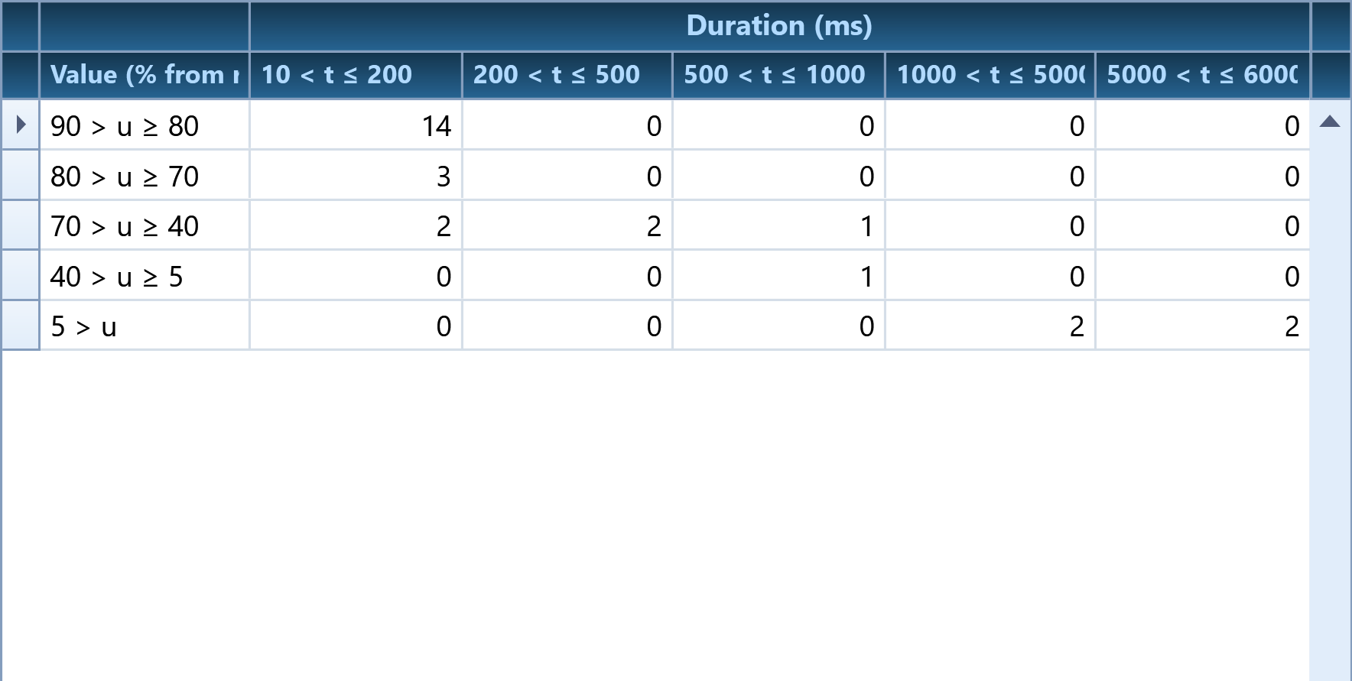
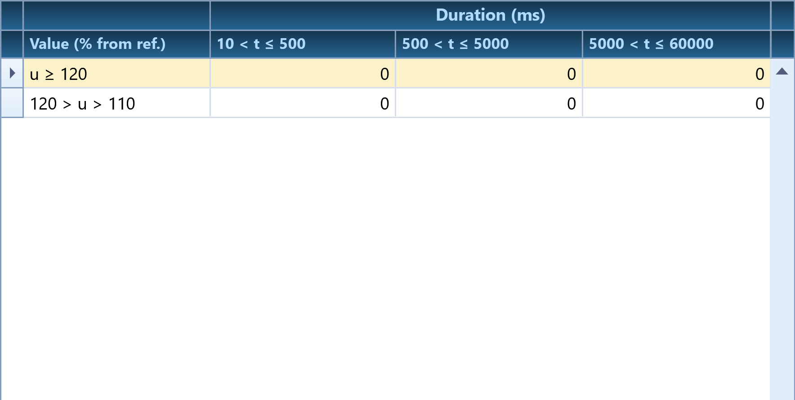

Charts Notes:

Chart: Spectrum: IEC 61000-4-30 Voltage and Current - Harmonics Amplitude (%) Voltage, PQZIP 02/13/2025 01:16:43 PM

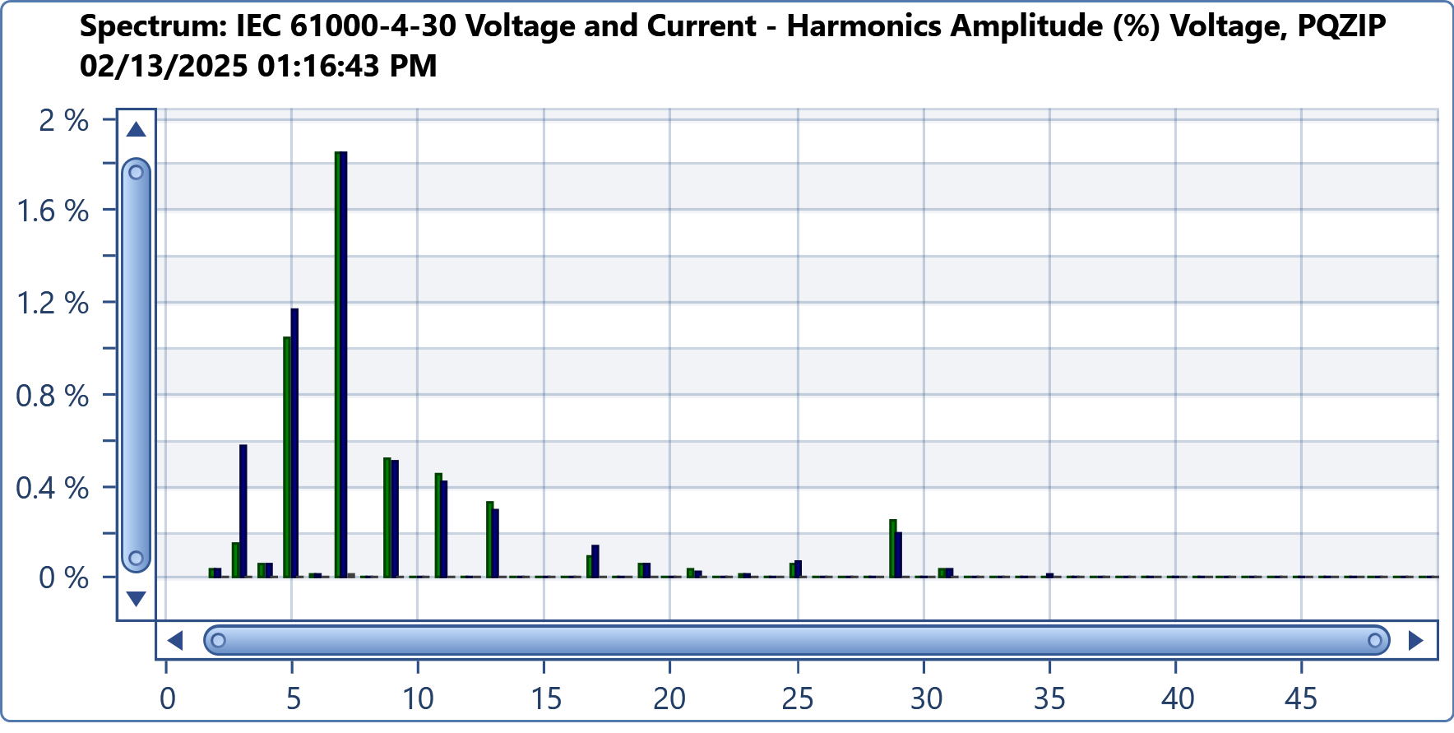

Charts Notes:

